# Configure API Versioning in api management

Pre-requisite:

* Need two APIs with version mentioned in the end-points.
* For demo purpose, we are using as below:

|  |  |  |
| --- | --- | --- |
| **API End-points** | **Version** | **Remarks** |
| [www.bing.com](http://www.bing.com) | V1 | In real time, this will have API with end-point containing version in it. |
| [www.google.com](http://www.google.com) | V2 | In real time, this will have API with end-point containing version in it. |

Steps:

1. Login to Azure Portal; navigate to respective resource group -> API Management Service.
2. Click on ‘APIs -Preview’
3. Go to Publisher Portal.
4. Click on ‘Add API’.

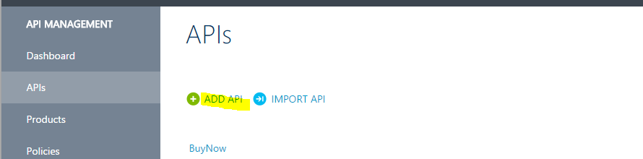

1. Enter the highlight fields and click Save.

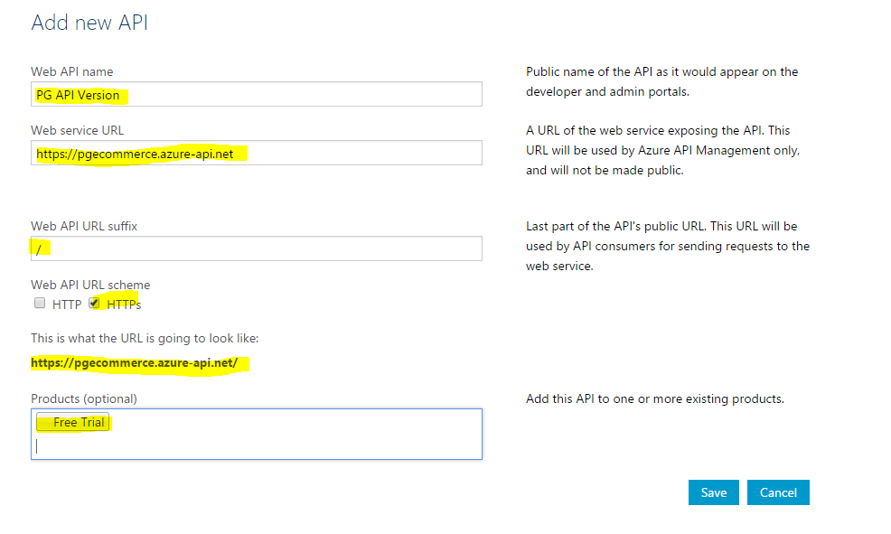

1. Click on ‘ADD Operation’.

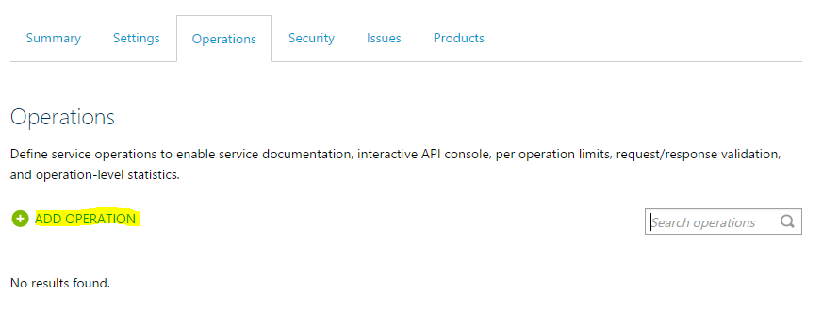

1. Enter the highlighted fields as below. Note: with GET methods enter URL template accordingly.

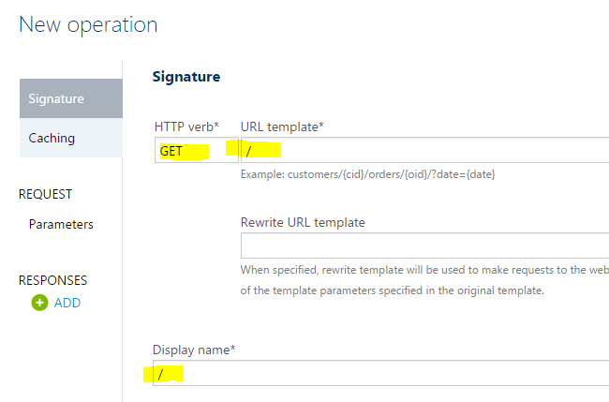

1. Enter Parameters as:

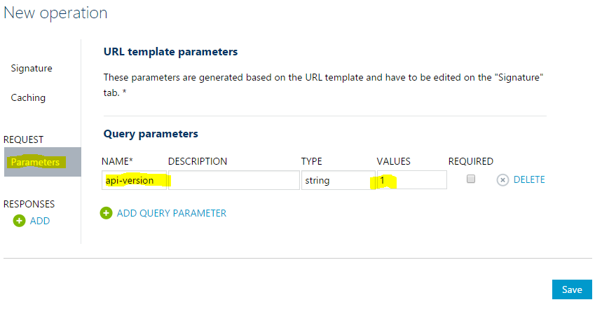

1. Click ‘Save’.
2. Go to Policy Editor; Policies -> PG API Version -> click on ADD Policy.

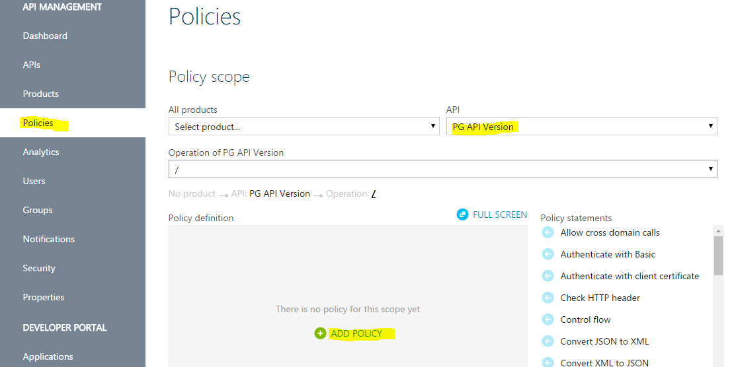

1. Enter the policy from attached text file, save and Exit.



Note: the above text file, replace the set-backend-service with proper end-points.

1. To test the policy. Navigate to API Management Service -> APIs – Preview.
2. Select the below highlighted fields under the selected API.

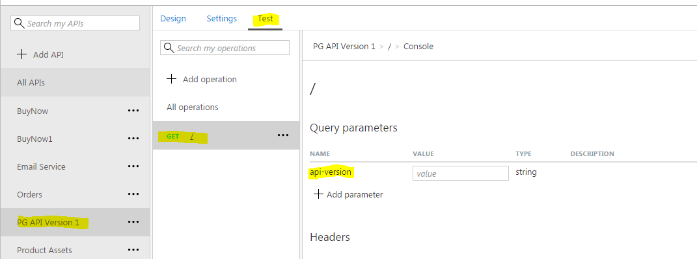

1. Enter Query Parameters as ‘1’. Click ‘Send’.
2. Below output displayed.

